Patient Information  Hospital number: Inpatient: Yes No  Title: Surname:  Forename(s):  Address:  Postcode:  Date of birth: / / Gender: Male Female  Contact Tel: Mobile No.:  Email:  Interpreter required: Yes No Language:  Appointment Booked: / / Time: |  | Payment Details  Payment Method: Insurance Embassy Self-Funding  Payment Provider:
Special Instructions
Book scan for week commencing: / /
Result of scan required by: / /
Previous imaging and/or report(s) attached:
MRI CT PET-CT Ultrasound
X-ray Nuclear Medicine Echocardiography
Additional Information
Patient transport: Walking Wheelchair Bed
Infection Risk: Yes No Details:

Allergies:
Claustrophobic: Yes No Pregnant: Yes No
Oxygen: Yes No Asthma: Yes No
Cardiac arrhythmia: Yes No
Recent surgery: Yes No Please specify:

Diabetic: Yes No
Diabetes controlled by: Diet Tablets Insulin
Weight: kg
Requested Procedure
MRI Nuclear Medicine*
CT Bone Densitometry*
PET-CT Ultrasound*
X-ray Other (please state)
Please provide details of the procedure(s):

CT/MRI  Reaction to contrast media: Yes No  Kidney disease/surgery: Yes No  Dialysis: Yes No  eGFR/ mL/min / /  Creatinine: mL/min / / | MRI  Metallic fragments in body: Yes No  Cardiac pacemaker/ICD: Yes No  Cochlear implant: Yes No  Intracranial aneurysm: Yes No  Other metallic implants: Yes No |  | PET-CT  Chemotherapy: Yes No  Last session: / / Next session: / /  Radiotherapy: Yes No Last session: / /  Recent biopsy: Yes No Specify where:
Clinical Indication for Examination
Please summarise relevant history, clinical findings and previous test results.

Please indicate the question that the examination aims to answer:

Referrer name:  GMC:  Address:  Postcode:  Tel:  Email:  Signature:  Date: / / |  | N.B. This form is a legal document – Referrer’s Declaration  The correct patient details have been provided. I have discussed the examination, including any intervention with the patient / guardian. I have taken into account the possibility of pregnancy.  I have given sufficient clinical information for the request to be justified according to IR(ME)R 2000 (if applicable). I will ensure that the examination results are recorded in the patient’s notes.
TO BE COMPLETED BY RB&HH STAFF ONLY
Imaging approved:

Authorising person:
Signature: Date: / /

*These tests will be undertaken at Royal Brompton Hospital
RB&HH Imaging Request Form – July-16 | Copyright © 2016

Important Information
To help ensure you are appropriately prepared for your scan, please discuss any of the following relevant points with your doctor prior to your appointment:
- Have you been advised that there is any special preparation for your test? Have been asked to fast or remain free of caffeine?
- Have you informed your doctor if you have any allergies, kidney problems or that you are taking any medications?
- Have you informed your doctor if you have any metal in your body such as a pacemaker, fragments or stents?
- Have you informed your doctor if you are pregnant?
- Have you informed your doctor if you have had any major surgery or illness recently?
- Please wear loose and comfortable clothing on the day of your scan and avoid wearing jewellery or clothes containing metal, such as zips.
Please be advised that if you have not been appropriately prepared, it may result in the cancellation of your test on the day. If you are in doubt about any of the above please contact our Imaging Department at your earliest convenience on
020 7351 8186 or diagnosticwimpole@rbht.nhs.uk
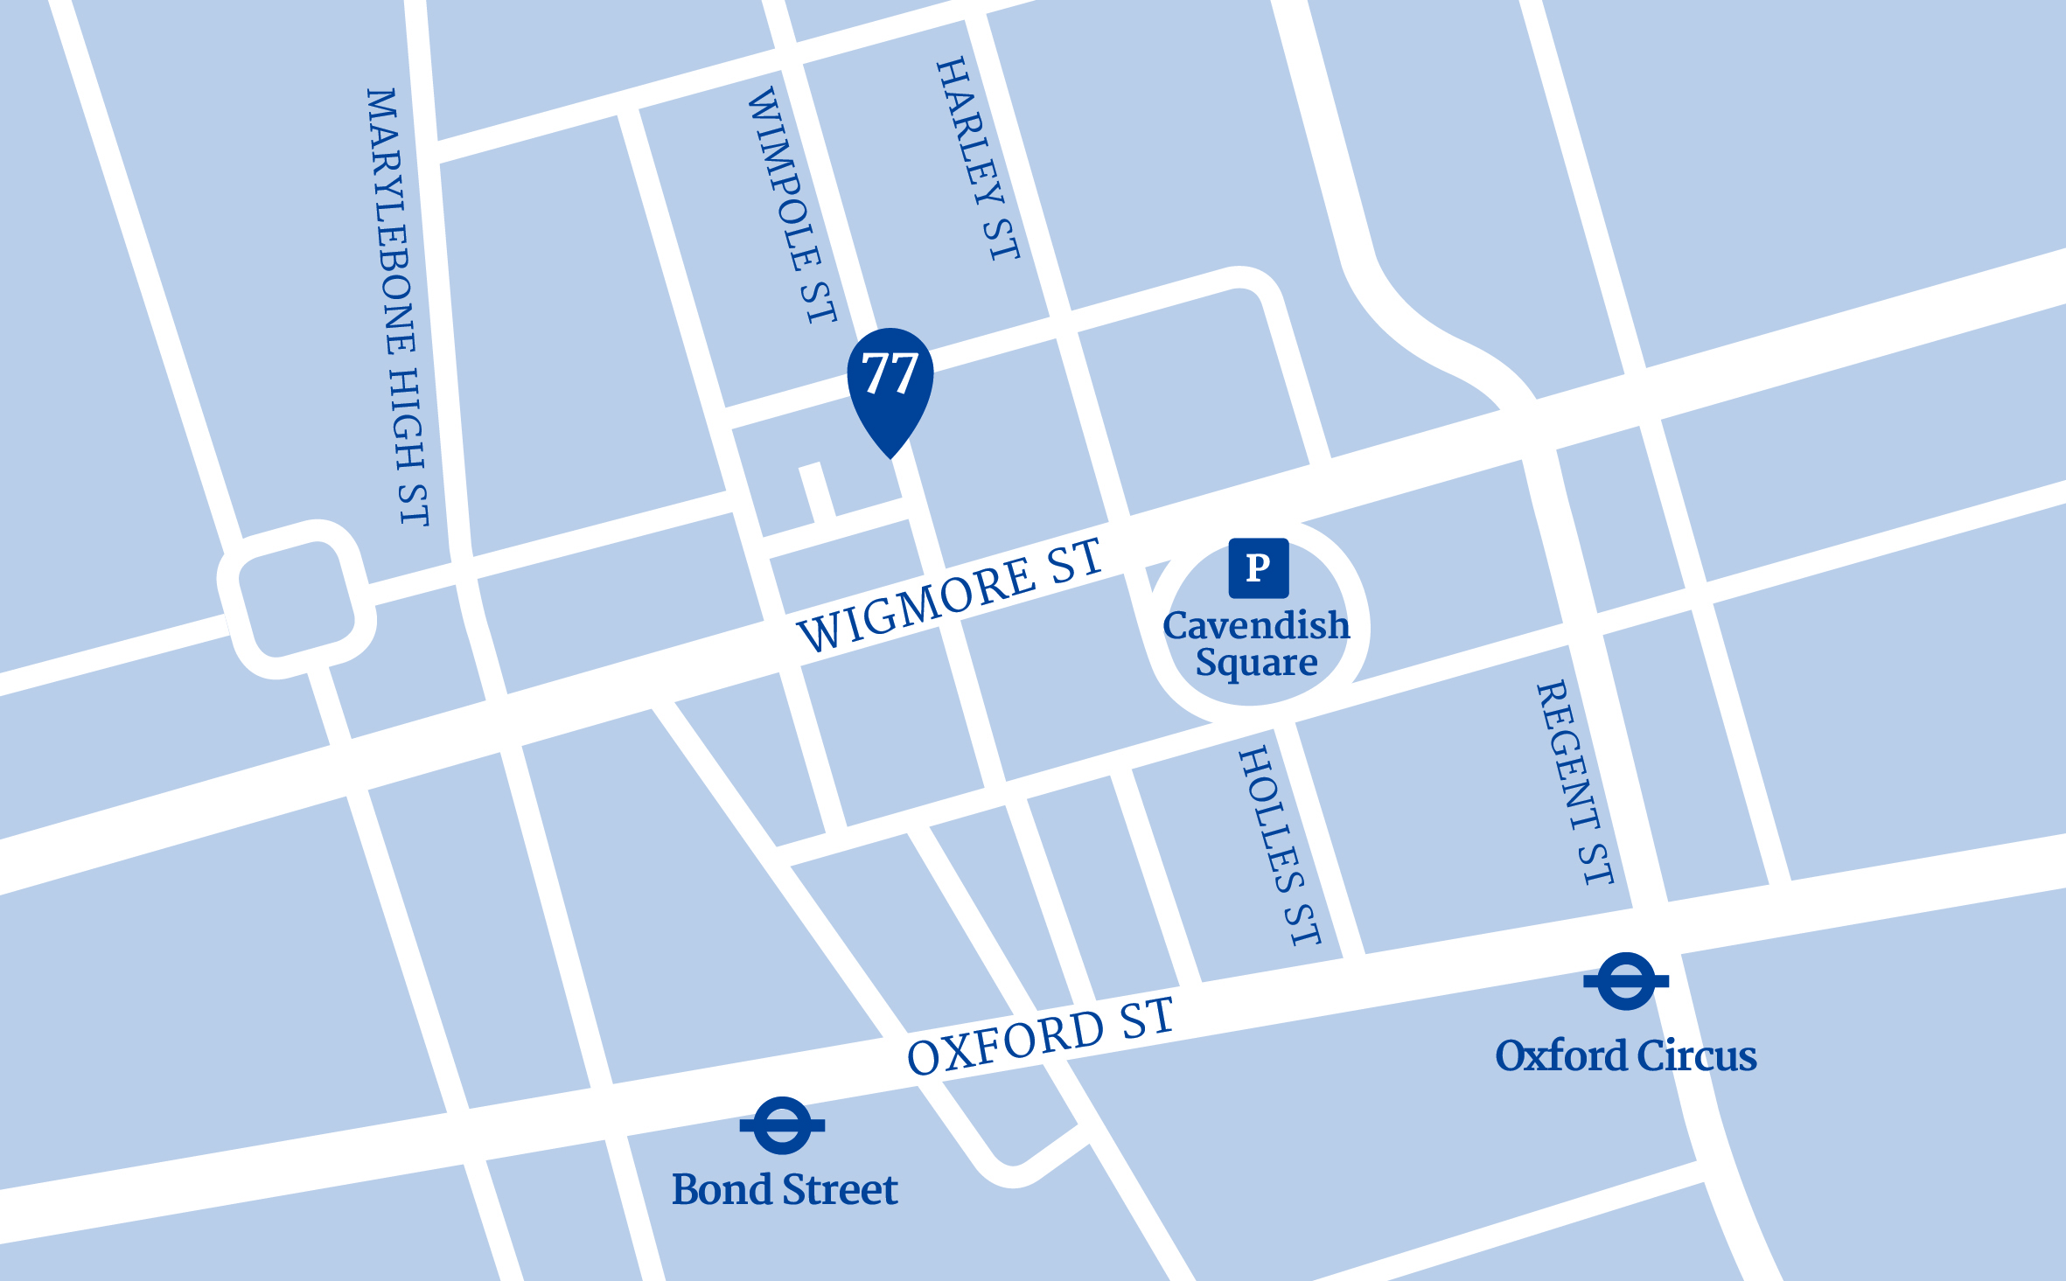
How to find us
Royal Brompton & Harefield Hospitals Specialist Care | Outpatients and Diagnostics | 77 Wimpole Street, London W1G 9RU
Tel: 020 7351 8186 | Email: rbh-tr.diagnosticwimpole@nhs.net | RB&HH Imaging Request Form – July-16 | Copyright © 2016
RB&HH Specialist Care Outpatients and Diagnostics is conveniently located in the Harley Street Medical Area and is easily accessible by public transport. Our entrance is located
at 77 Wimpole Street.
By underground
It is less than 10 minutes walk from both Oxford Circus Station, which is on the Central, Bakerloo and Victoria Lines, and Bond Street Station via the Central and Jubilee Lines.
By bus
A number of buses serve Oxford Street, which is less than
10 minutes walk to our location.
By car
Paid public car parking (P) is available at Q-Park Oxford Street, Cavendish Square, W1G OPN. You can pre-book your parking through the Q-Park website: www.q-park.co.uk
RB&HH Specialist Care Outpatients and Diagnostics is inside London’s Congestion Charge zone. Please note that you are responsible to ensure you make this payment. For further travel options and directions please visit tfl.gov.uk

