Patient Information  Hospital number: Inpatient: Yes No  Title: Surname:  Forename(s):  Address:  Postcode:  Date of birth: / /  Gender: Male Female  Contact Tel:  Mobile No.:  Email:  Interpreter required: Yes No Language:  Appointment Booked: / / Time: | Payment Details  Payment Method: Insurance Embassy Self-Funding  Payment Provider:
Requested Respiratory Procedure
Spirometry
Gas Transfer
Static Lung Volumes (Plethysmography)
Bronchodilator response: Ventolin Atrovent
End Capillary Blood Gases
Cardiopulmonary Exercise Test (Respiratory)
If other tests required please specify:

Additional Information  Patient transport: Walking Wheelchair Bed  Infection Risk: Yes No Details:  Allergies:  Pregnant: Yes No  Oxygen: Yes No  Asthma: Yes No  Beta Blockers: Yes No  Recent syncope: Yes No  Diabetic: Yes No Controlled by: Diet Tablets Insulin  Recent surgery: Yes No  Please specify surgery: | Relative Contraindications:  Please complete if Spirometry requested  Haemoptysis of unknown origin: Yes No  Recent pneumothorax: Yes No  Recent myocardial infarction: Yes No  Pulmonary embolism: Yes No  Thoracic, abdominal or cerebral aneurysms: Yes No  Recent eye surgery; raised intra-ocular pressure: Yes No  Recent thoracic or abdominal surgical procedures: Yes No  Cervical neck problems: Yes No  Any other physical problem: Yes No
Clinical Indication for Examination
Please summarise relevant history, clinical findings and previous test results.

Please indicate the question that the examination aims to answer:

Referrer name:  GMC:  Address:  Postcode:  Tel:  Email: | N.B. This form is a legal document – Referrer’s Declaration  The correct patient details have been provided. I have discussed the examination, including any intervention with the patient / guardian. I have taken into account the possibility of pregnancy. I have given sufficient clinical information for the request to be justified according to IR(ME)R 2000 (if applicable). I will ensure that the examination results are recorded in the patient’s notes.
Signature:
Date: / /
RB&HH Lung Function Request Form – July-16 | Copyright © 2016

Important Information
To help ensure you are appropriately prepared for your test, please discuss any of the following relevant points with your doctor prior to your appointment:
- Have you been advised that there is any special preparation for your test? Have been asked to fast or remain free of caffeine?
- Have you informed your doctor if you have any allergies, kidney problems or that you are taking any medications?
- Have you informed your doctor if you are pregnant?
- Have you informed your doctor if you have had any major surgery or illness recently?
- Please wear loose and comfortable clothing.
Please be advised that if you have not been appropriately prepared, it may result in the cancellation of your test on the day. If you are in doubt about any of the above please contact our Diagnostics Booking Team at your earliest convenience on
020 7351 8186 or diagnosticwimpole@rbht.nhs.uk
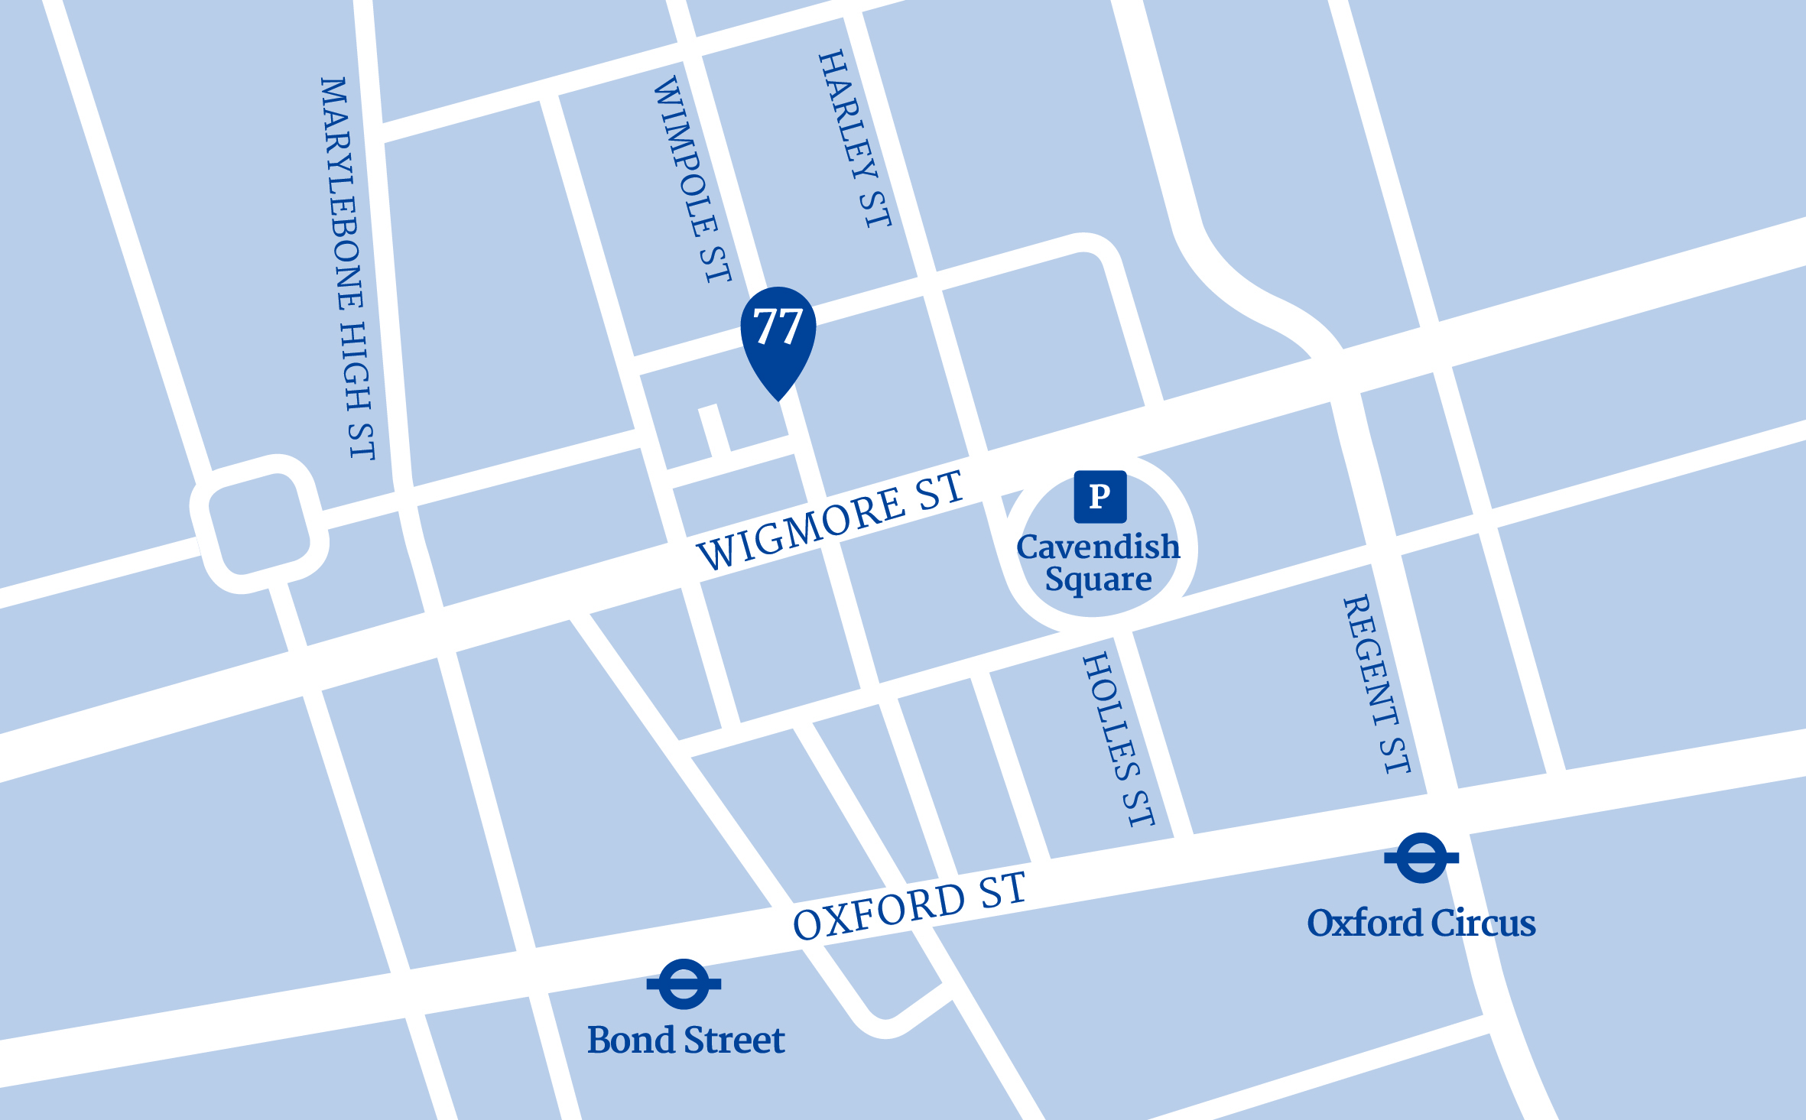
How to find us
RB&HH Specialist Care Outpatients and Diagnostics is conveniently located in the Harley Street Medical Area and is easily accessible by public transport. Our entrance is located
at 77 Wimpole Street.
By underground
It is less than 10 minutes walk from both Oxford Circus Station, which is on the Central, Bakerloo and Victoria Lines, and Bond Street Station via the Central and Jubilee Lines.
By bus
A number of buses serve Oxford Street, which is less than
10 minutes walk to our location.
By car
Paid public car parking (P) is available at Q-Park Oxford Street, Cavendish Square, W1G OPN. You can pre-book your parking through the Q-Park website: www.q-park.co.uk
RB&HH Specialist Care Outpatients and Diagnostics is inside London’s Congestion Charge zone. Please note that you are responsible to ensure you make this payment. For further travel options and directions please visit tfl.gov.uk

